Customer Satisfaction Survey

Dating back to 2010 (and approximately two weeks after a database has been supplied) every customer of Responsiva’s is invited to take part in a customer satisfaction survey.
There are just five check-box questions, enabling Responsiva to learn from customer feedback and implement positive improvements as and where necessary. The results follow.

Q1 Please rank Responsiva's speed of service
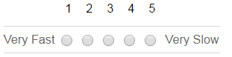
Q2 Please comment on the price you paid for data
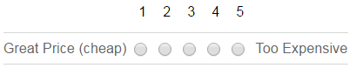
Q3 Was the data accurately specified?
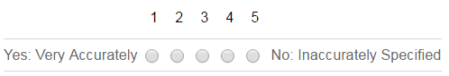
The average speed of service has been steady, between 1.1 and 1.3, with the ‘perfect’ score being 1. More than 90% of orders are delivered within one hour.
The price of data ranged from 2.0 to 2.5, with the average being 2.3. Responsiva doesn’t aim to be the cheapest, but strive to maintain a fair price.
Responsiva regards the data specification element to be of paramount importance. This has ranged from 1.6 to 2.0, and an average of 1.8 (the perfect score is 1.0). Our 2017 goal is to get this below 1.5.
Q4 Would you purchase data from Responsiva again?
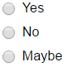
Year on year the response has varied between 80% and 93% saying “YES”. The average being 86%.
Only two customers have ever clicked “NO”.
And the remainder (13%) have clicked “MAYBE”.

Q5 Would you refer Responsiva to one of your clients, suppliers or business colleagues?
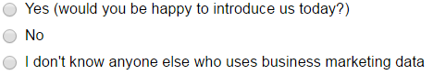
The responses have varied between 80% and 91% saying “YES”. The average being 84%.
12% have stated that they don’t know anyone else who uses business marketing data, and 4% wouldn’t refer.

Please add any free text comments on how Responsiva can improve its service
There have been many hundreds of free text comments; offering constructive support, praise, thanks etc. These have all been read, appreciated and (where possible) actioned for positive change. Below are the four most recent feedback comments (copied word for word) from the last few weeks;

- Great service as always and I have passed your details onto 2 of our clients. Would like to see an introducers reward.

- It's impossible to provide 100% accurate data particularly when some businesses register themselves under a very generic SIC CODE, however, Toby has always been able to provide us with excellent data and a very low error rate.

- You get more than data from Responsiva, you get their knowledge which helps inform the data purchase, ultimately leading higher sales.

- Having extensive experience in the data world from both end of the spectrum, selling and buying and currently working in a fast pace marketing environment, dealing with Toby was a pleasure and certainly made my job a lot easier, I genuinely wish all commercial relationship were that professional and smooth.

